|  |  |
| --- | --- |
|  | **FPT ACADEMY INTERNATIONAL**  **FPT – APTECH COMPUTER EDUCATION** |

**Centre Name: ACE-HCMC-2-FPT.**

**Address: 590 Cach Mang Thang 8, District 3, Ho Chi Minh City, Viet Nam.**

**SCHOOLSINFO**

**EPROJECT-SEMESTER1**



|  |  |  |
| --- | --- | --- |
| **Supervisor:** | Ngo Phuoc Nguyen | |
| **Semester:** | 1 | |
| **Batch No:** | T1.2009.A0 | |
| **Group No:** | 05 | |
| **Order:** | **Full name** | **Roll No.** |
| 1. | Lay Chan Giang | Student1279106 |
| 2. | Hoang Van Thao | Student1279126 |
| 3. | Vu Quy Thien Anh | Student1279127 |
| 4. | Dao Thanh Thien | Student1279123 |

Month 12 Year 2020

This is to certify that

**Mr. LAY CHAN GIANG**

**Mr. HOANG VAN THAO**

**Mr. VU QUY THIEN ANH**

**Mr. DAO THANH THIEN**

Have successfully Designed & Developed

SCHOOLSINFO

Submitted by:**LAY CHAN GIANG**

Date of Issue:December 18th 2020

Authorized Signature:

ACKNOWLEDGEMEN

Review 1

A. Problem Definition

Problem identify

User

B. Specification required by the user

TASK SHEET REVIEW 1

Review 2

Site Map

Mock

1. Home Page

2. Introduction

3. University

4. Info University

5. Graduation Anniversary

6. About Us

7. Contact

TASK SHEET REVIEW 2

Scope Of The Work (In Brief)

ARCHITECTURE AND DESIGN OF THE SYSTEM

DIAGRAM OF THE WEBSITE

WEBSITE DESCRIPTION

1. Home Page

2. Schoolsinfo

3. University

4. Graduation Anniversary

5. About Us

6. Contact

7. Diagram 7

JAVASCRIPT…………………………………………………………………………………………………………………………29

1.Check input form contact………………………………………………………………………………………….29

2.Accordion………………………………………………………………………………………………………………….30

TASK SHEET REVIEW 3 ………………………………………………………………………………………………………31

ACKNOWLEDGEMEN

First of all, we are thankful to Mr. Nguyen Ngo Phuoc for supporting us on the project and the cooperation of each team’s member. The project couldn’t be finished without their hard work. The project help us get more experience in team working and problem solving. It gives us a lot of confidence to face an interview as us have worked on a project.

Finally, we express our gratitude toward our families and colleagues for their kind cooperation and encouragement which help us in completion of this project.

Review 1

1. Problem Definition

Currently, the learning needs of many students do not meet the needs, why schools do not make an online message board to highlight their attention.

In the TOP list of the world's top universities, the U.S. always has many universities on the list. American degree is not only popularly recognized but also appreciated in the world.

The success of U.S. higher education is based on a combination of advanced teaching facilities and technologies, excellent faculty, and intensive professionalization and interest in individual development.

Problem identify

* Give the viewer the purpose of the site's existence.
* This allows users to easily search for information.
* Provide users with relevant information about different schools in the region.
* Provide common questions and answers to schools they need to find.
* Provides a convenient interface for users.

User

* Easily find the school you want.
* All other schools in the area can be referenced.
* Can comment to the administrator.
* You can get a better understanding of universities.

1. Specification required by the user

The Web site is to be created based on the following requirements.

1. There should be a separate website to see the specifics of the university.
2. We have to make it easier for people to find information in the same section.
3. Provide some articles about universities.
4. Also provide other things such as libraries, boarding ...

**HARDWARE/ SOFTWARE REQUIREMENTS**

❖ **For webmaster**

**Hardware**

• Intel Pentium 4 processor or higher

• 1 Gigabytes of RAM or higher

**Software**

• Windows 7 OS or higher

• Visual Studio Code

• Bootstrap 4.

• HTML5 and Javascript supporting web browsers such as IE, Chrome, Firefox,

Opera…

❖ **For web users**

**Hardware**

• Intel Pentium 4 processor or higher

• 512 Megabytes of RAM or higher

**Software**

• Windows XP OS or higher

• HTML5 and Javascript supporting web browsers such as IE, Chrome,

Opera… *(Website best running on Chrome browser)*

TASK SHEET REVIEW 1

|  |  |  |  |  |  |  |  |
| --- | --- | --- | --- | --- | --- | --- | --- |
| **Project Ref. No.:**  **eP/Advertisement** **Portal Management** **System/01** | | **Project Title:** | **Activity Plan** **Prepared** **By:** | **Date of Preparation of Activity Plan:** | | | |
| **Sr.No.** | **Task** | **Actual Start** **Date** | **Actual** **Days** | **Team** **Mate** **Names** | **Status** |
| 1 | Problem Definition | SchoolsInfo | TEAM | 30/11/20 | 1 | GIANG | Completed |
| 2 | Problem Indentify | 30/11/20 | 1 | GIANG | Completed |
| 3 | User | 30/11/20 | 1 | GIANG | Completed |
| 4 | Customer Requirements Specification | 30/11/20 | 1 | GIANG | Completed |

|  |  |
| --- | --- |
| **Date:** | |
| Signature of Instructor:  **Mr: Ngo Phuoc Nguyen** | Signature of Team Leader:  **Lay Chan Giang** |

Review 2

Site Map

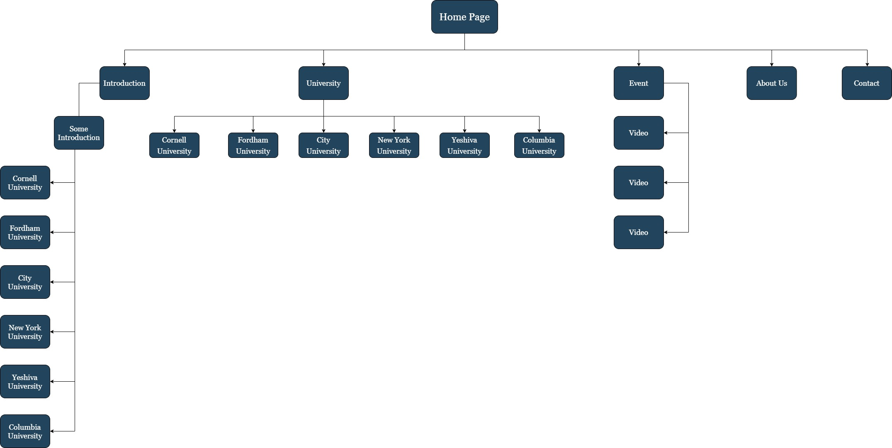

Mock

1. Home Page

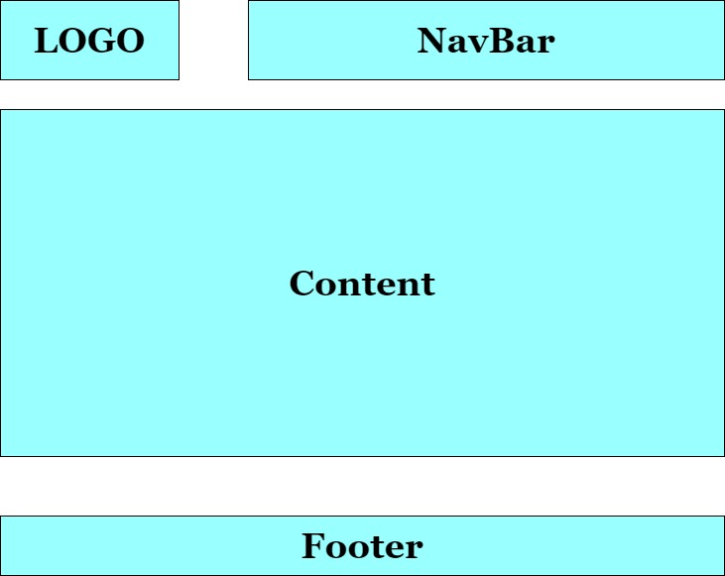

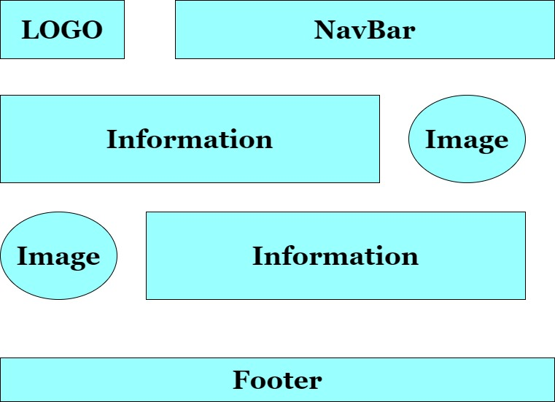2.Introduction

3.University

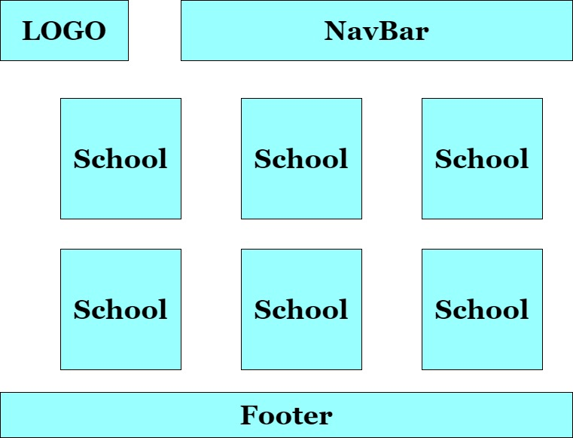

4.Info University

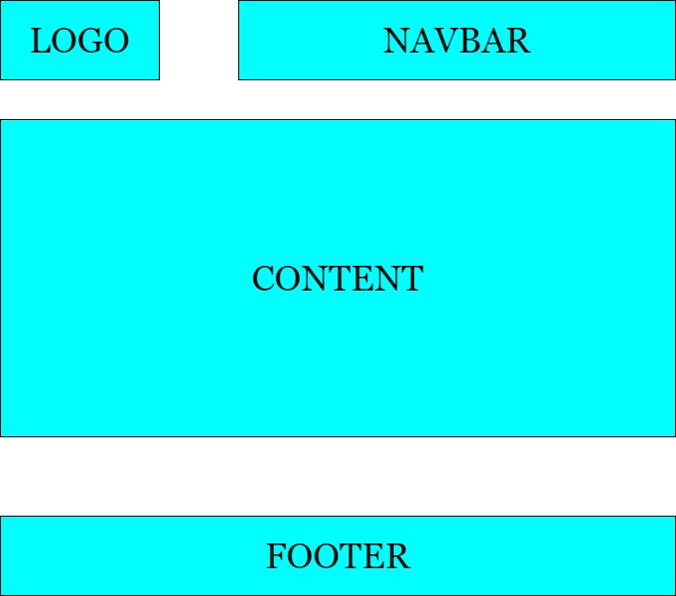

5. Graduation Anniversary

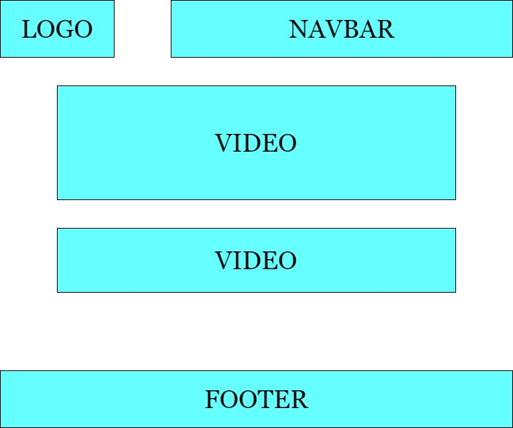

1. About Us

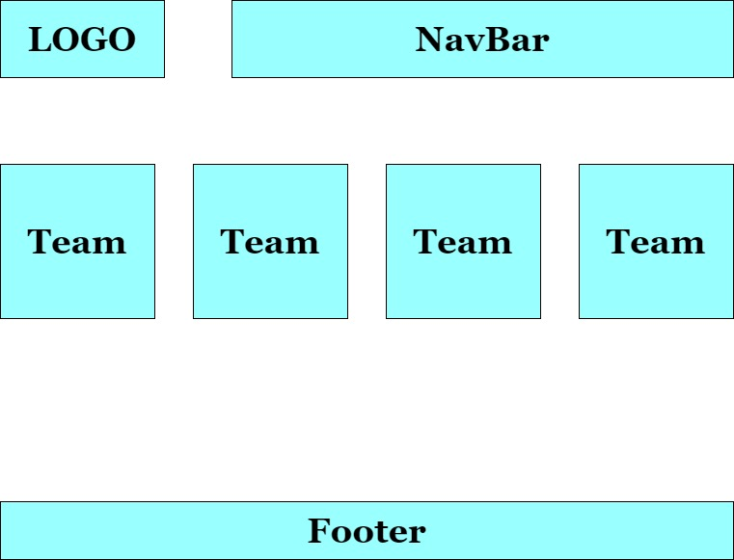

1. 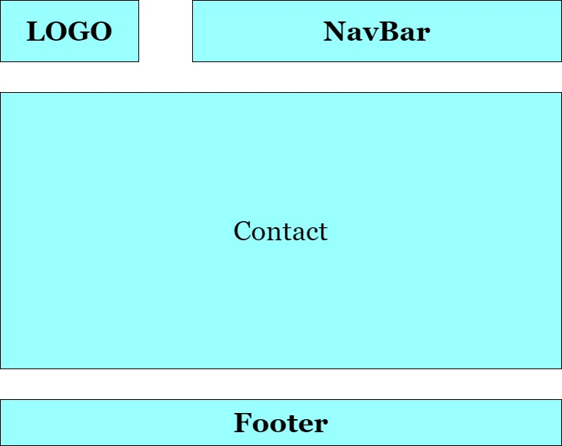Contact

TASK SHEET REVIEW 2

|  |  |  |  |  |  |  |  |
| --- | --- | --- | --- | --- | --- | --- | --- |
| **Project Ref. No.:**  **eP/Advertisement** **Portal Management** **System/01** | | **Project Title:** | **Activity Plan** **Prepared** **By:** | **Date of Preparation of Activity Plan:** | | | |
| **Sr.No.** | **Task** | **Actual Start** **Date** | **Actual** **Days** | **Team** **Mate** **Names** | **Status** |
| 1 | Site Map | SchoolsInfo | GIANG | 9/12/20 | 1 | GIANG | Completed |
| 2 | Mock | 9/12/20 | 1 | GIANG | Completed |
| 3 | Review 2 | 9/12/20 | 1 | GIANG | Completed |

|  |  |
| --- | --- |
| **Date:** | |
| Signature of Instructor:  **Mr: Ngo Phuoc Nguyen** | Signature of Team Leader:  **Lay Chan Giang** |

Scope Of The Work (In Brief)

After a long and detailed discussion, our group has decided to create a website contain the following webpages:

1. Homepage : show the information of some universities, where parents or students need to find and see more information from the school they need to find.
2. SchoolsInfo: show some introductions to each university.
3. University: This website will give you all the specific information about the universities you need to find such as history, libraries, boarding …
4. Graduation Anniversary: show some videos of school graduation ceremonies.
5. About Us: information about our group, birthday, gender, occupation, contact information.
6. Contact: where you logged in your information to let us know that you visited this place.

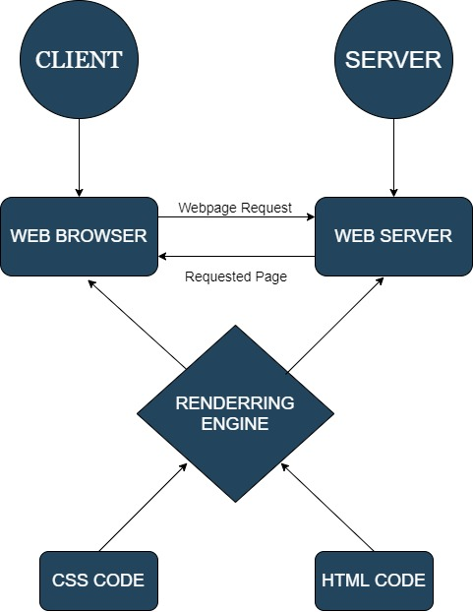ARCHITECTURE AND DESIGN OF THE SYSTEM

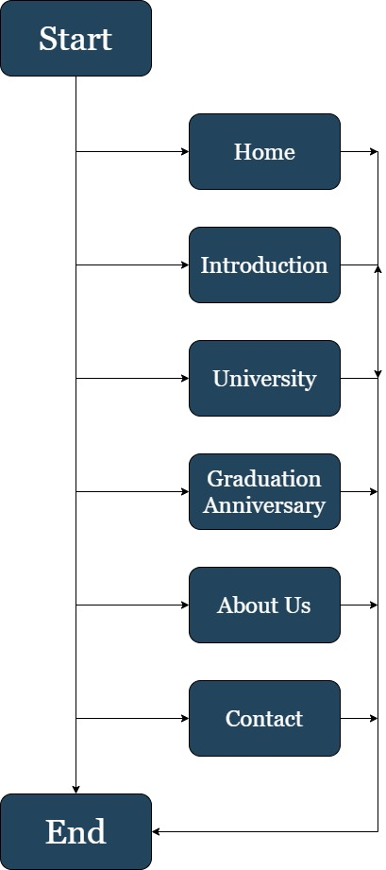DIAGRAM OF THE WEBSITE

WEBSITE DESCRIPTION

1. Home Page

* Description

Homepage : show the information of some universities, where parents or students need to find and see more information from the school they need to find.

* Screenshot

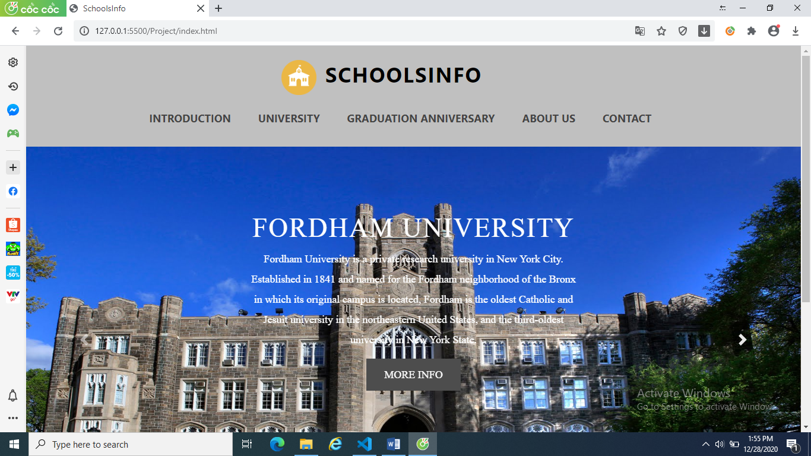

1. Schoolsinfo

* Description

SchoolsInfo: show some introductions to each university.

* Screensshot



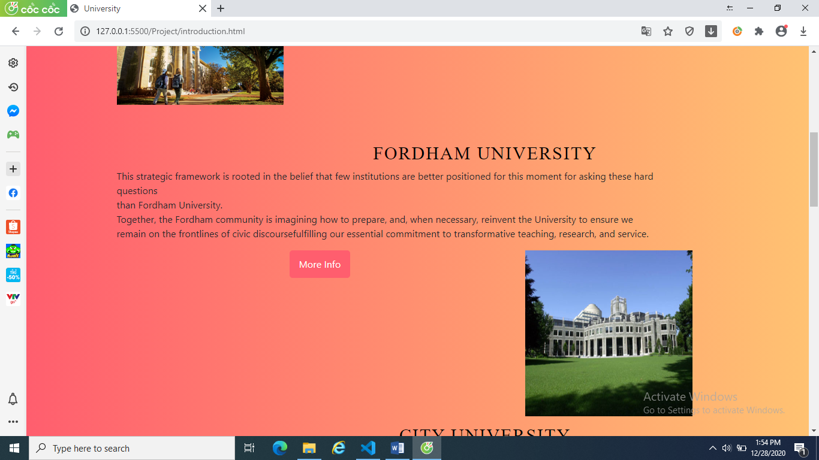

1. University

* Description

University: This website will give you all the specific information about the universities you need to find such as history, libraries, boarding …

* 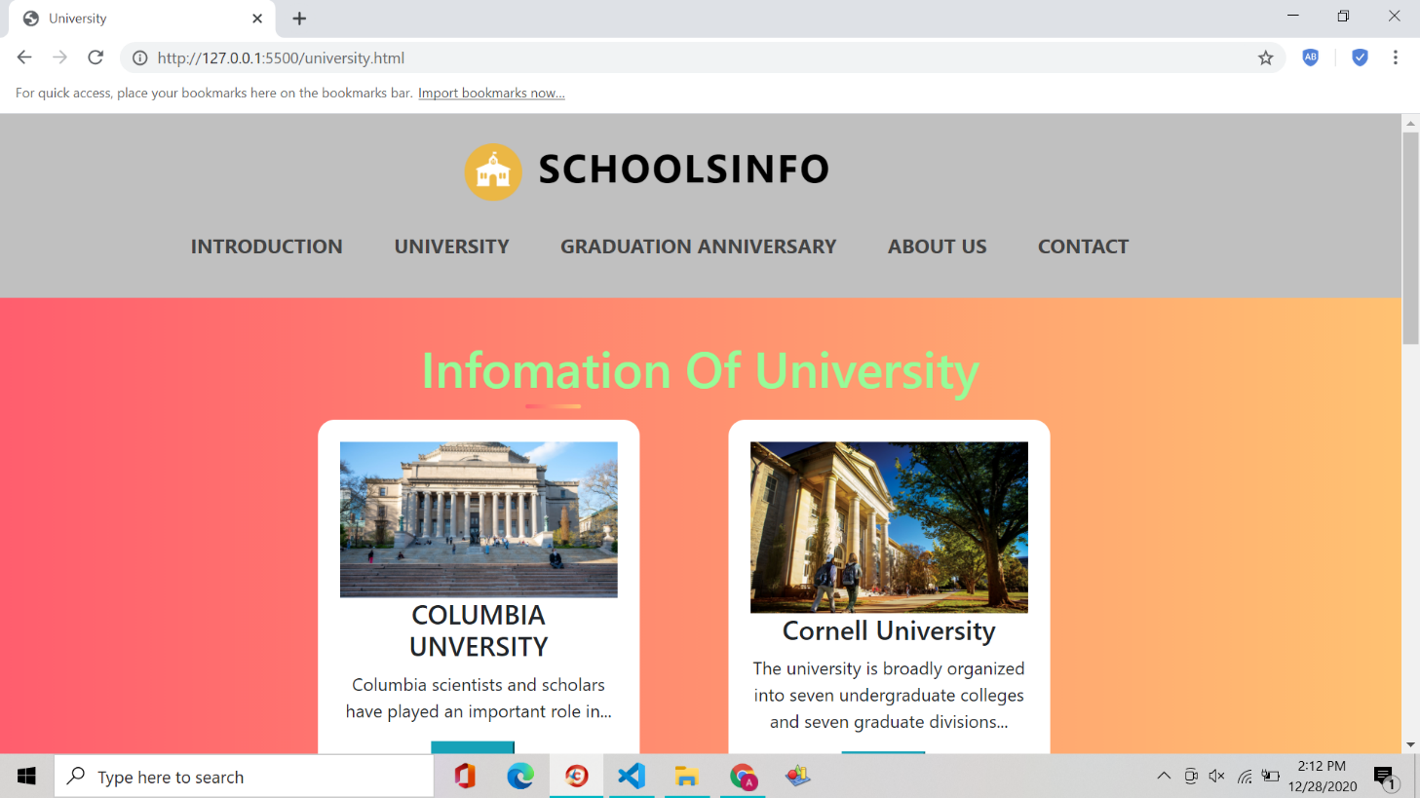Screenshot

­­­­­­­

1. Graduation Anniversary

* Description

Graduation Anniversary: show some videos of school graduation ceremonies.

* 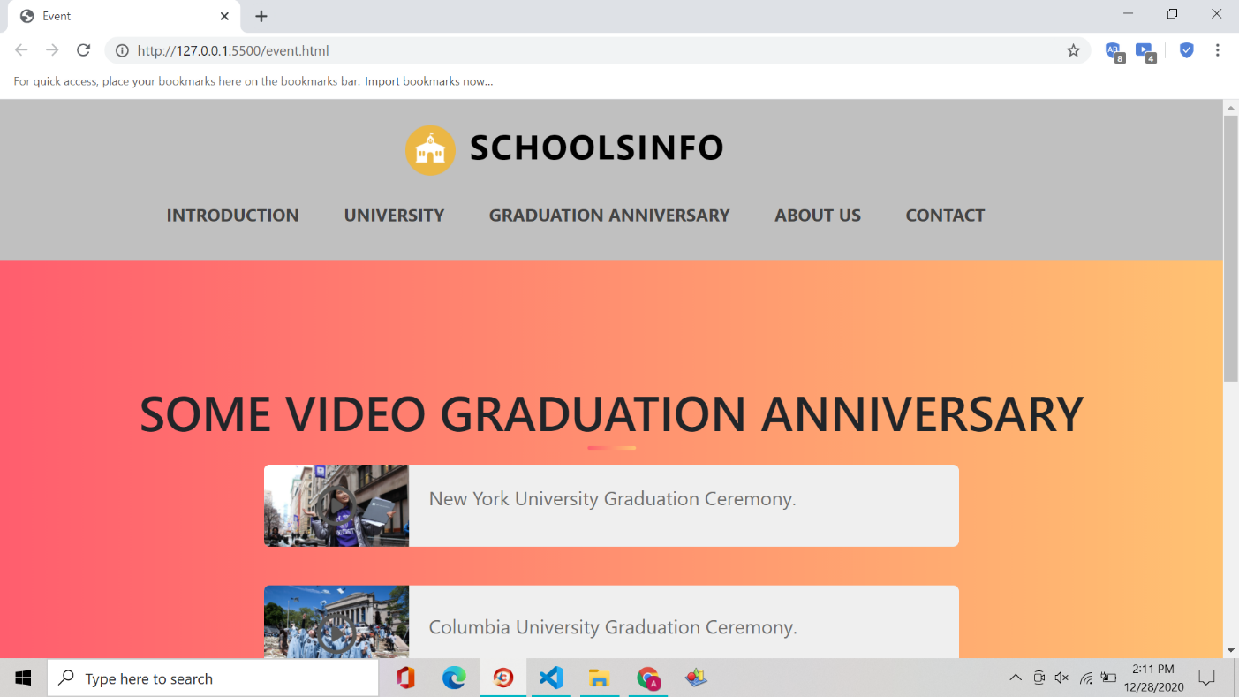Screenshot

1. About Us

* Description

About Us: information about our group, birthday, gender, occupation, contact information.

* Screenshot

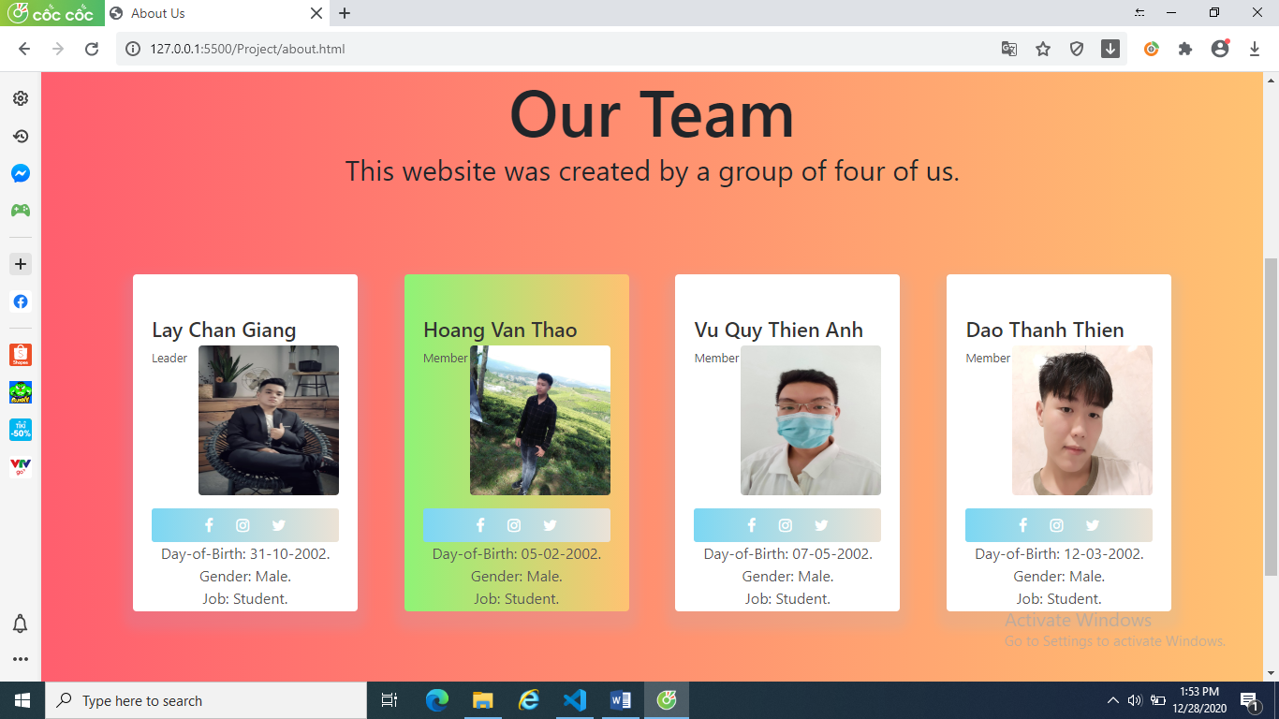

1. Contact

* Description

Contact: where you logged in your information to let us know that you visited this place.

* Sceenshot

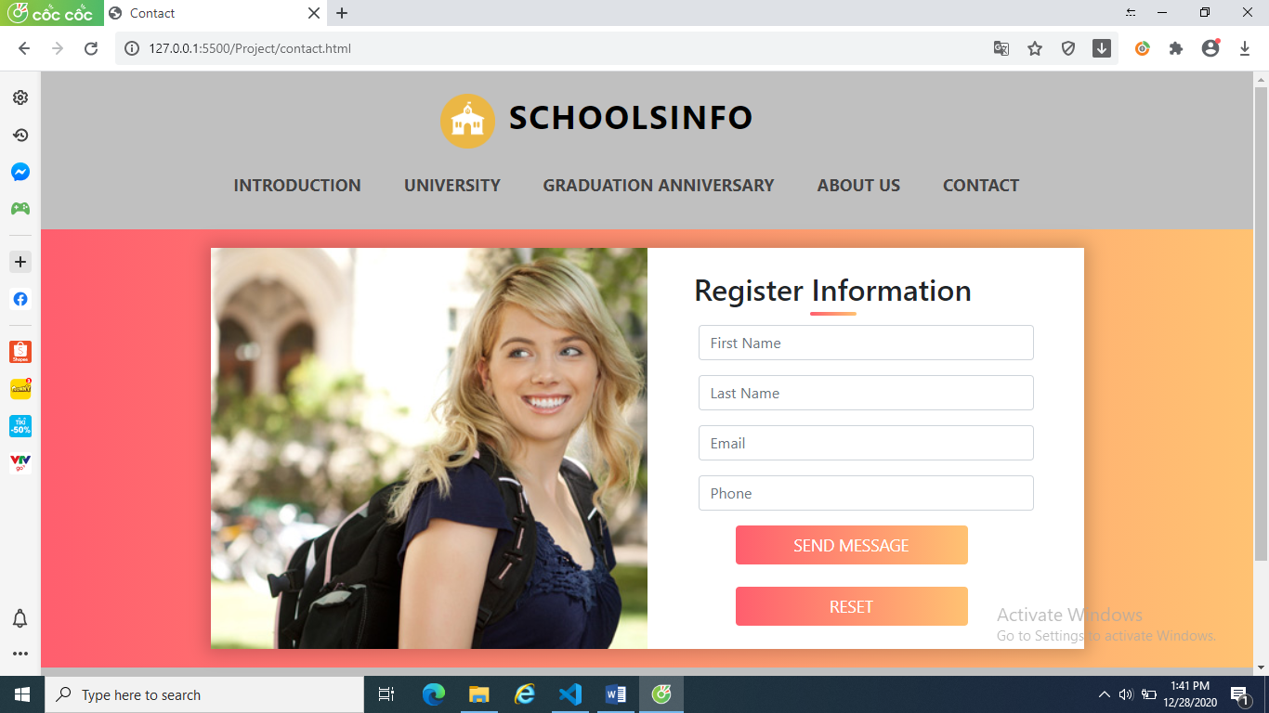

1. Diagram

* Description

The block diagram depicts the activities of the website allowing the user to understand and understand the sequence of the website

* Sceenshot

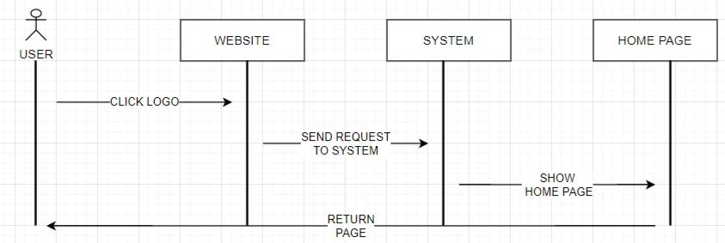

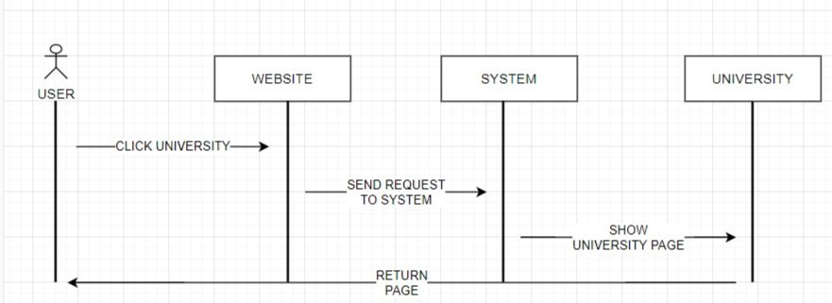

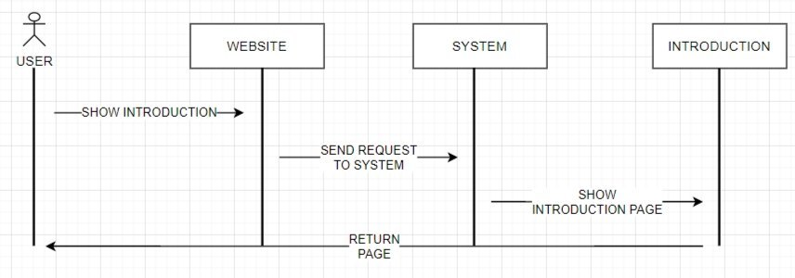

TASK SHEET REVIEW 2

|  |  |  |  |  |  |  |  |
| --- | --- | --- | --- | --- | --- | --- | --- |
| **Project Ref. No.:**  **eP/Advertisement** **Portal Management** **System/01** | | **Project Title:** | **Activity Plan** **Prepared** **By:** | **Date of Preparation of Activity Plan:** | | | |
| **Sr.No.** | **Task** | **Actual Start** **Date** | **Actual** **Days** | **Team** **Mate** **Names** | **Status** |
| DOCUMENT | | SchoolsInfo | GIANG |  |  |  |  |
| 1 | Home page | 9/12/20 | 1 | GIANG | Completed |
| 2 | Introduction | 9/12/20 | 1 | GIANG | Completed |
| 3 | University | 9/12/20 | 1 | GIANG | Completed |
| 4 | Graduation Anniversary | 9/12/20 | 1 | GIANG | Completed |
| 5 | About Us | 9/12/20 | 1 | GIANG | Completed |
| 6 | Contact | 9/12/20 | 1 | GIANG | Completed |
| 7 | Diagram | 23/12/20 | 1 | THAO | Completed |
| **Code** | |  |  |  |  |
| 1 | Homepage | 1/12/20 | 1 | GIANG,  THAO | Completed |
| 2 | Introduction | 2/12/20 | 1 | GIANG,  THAO | Completed |
| 3 | University | 3/12/20 | 1 | THAO  ,ANH | Completed |
| 4 | Graduation Anniversary | 4/12/20 | 1 | GIANG,  ANH | Completed |
| 5 | About Us | 5/12/20 | 1 | GIANG,  THAO | Completed |
| 6 | Contact | 6/12/20 | 1 | GIANG  ,THAO | Completed |

JAVASCRIPT

1.Check input form contact

* Description

Check whether the input data matches the format requirements or not. If the data entered does not match, an error will be reported. If appropriate the data will be sent

* ScreenShot

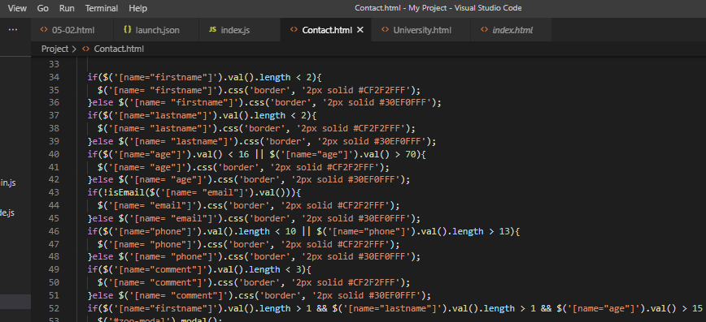

2.Accordion

* Description

Accordions are useful when you want to toggle between hiding and showing large amount of content

* 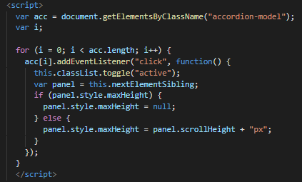Screenshot

|  |
| --- |
| TASK SHEET REVIEW 3 |

|  |  |  |  |  |  |  |  |  |  |  |  |  |  |  |  |
| --- | --- | --- | --- | --- | --- | --- | --- | --- | --- | --- | --- | --- | --- | --- | --- |
| **Project Ref. No.:**  **eP/Advertisement** **Portal Management** **System/01** | | **Project Title:** | **Activity Plan** **Prepared** **By:** | **Date of Preparation of Activity Plan:** | | | | 1 | Homepage |  |  | 1/12/20 | 1 | GIANG | Completed |
| **Sr.No.** | **Task** | **Actual Start** **Date** | **Actual** **Days** | **Team** **Mate** **Names** | **Status** |
| DOCUMENT | | SchoolsInfo | TEAM |  |  |  |  |
| 1 | Dowload | 23/12/20 | 1 | ANH | Completed |
| 2 | Word | 23/12/20 | 1 | THIEN | Completed |
| 3 | Github | 23/12/20 | 1 | THIEN,  ANH | Completed |
| 4 | Find images and materials | 23/12/20 | 1 | THAO,  THIEN,  ANH | Completed |
| 5 | Code synthesis | 23/12/20 | 1 | GIANG | Completed |
| 6 | Javascript |  |  | 23/12/20 | 1 | THAO | Completed |